**ASSIGNMENT 4**

COMPLEX NUMBER

**Problem Statement** :-

Design a C++ Class 'Complex' with data members for real and imaginary part. Provide default and parameterized constructors. Write a program to perform arithmetic operations of two complex numbers using operator overloading (using either member functions or friend functions).

**Learning Objectives** :-

i. Complex number Algebra

ii. Operator Overloading

**Theory** :-

**What is Complex Number**

Operations on Complex Numbers

**Operator overloading :-**

Unary Operators Overloading :-

Binary Operators Overloading :-

**Related Mathematics** :-

C = { a + ib | a, b |R and i = i.e. }

The set C represents a complex number.

Input :- Ci = { r, i }

The set C represents complex number including real number (r) and imaginary number

(i)C = {C1, C2, C3, ………….., Cn}

The set C represents set of complex numbers.

//Output :-

A = ( C, +, -, *, /)

A represents an algebraic system consisting of set C and functions (in this case operators)

The operators +, -, *, / are performed on set C.

**Venn diagram** :

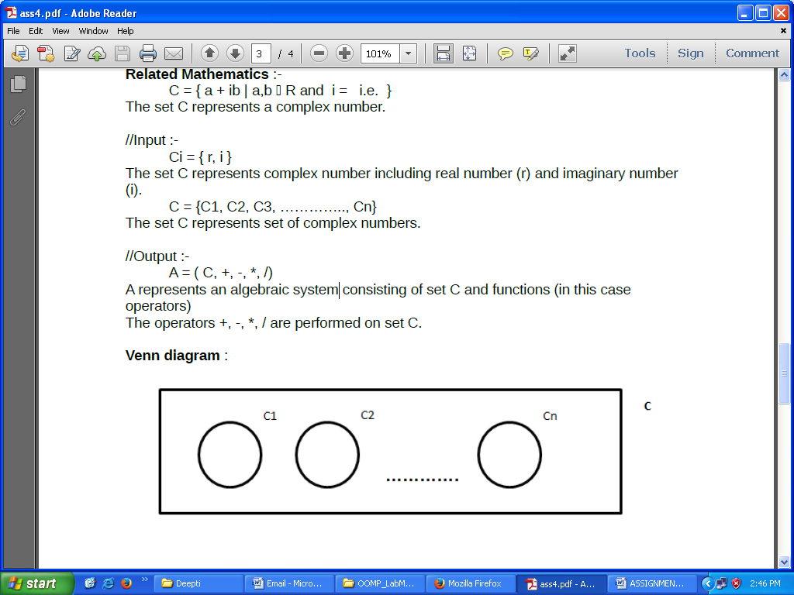

**Conclusion** :-

Using operator overloading, we can perform operations on complex numbers.